CRITIQUING VISUALS AND REFLECTION

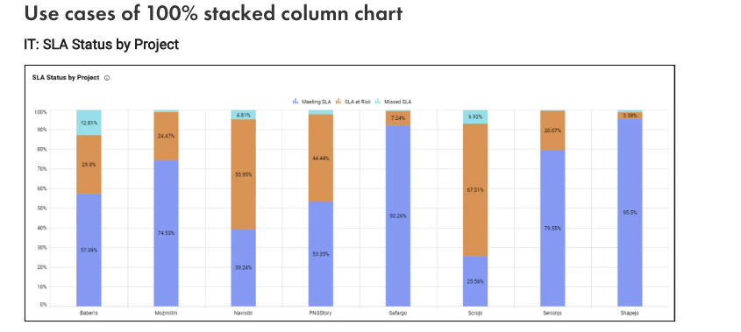
https://www.boldbi.com/blog/100-stacked-column-chart-data-proportions/
IT: SLA Status by Project

The stacked column chart titled "SLA Status by Project" on boldbi.com/blog visually represents the SLA (Service Level Agreement) status across different projects. The chart's goal is to provide a clear and comparative view of how well various projects are meeting their SLAs over a specified period.
The primary objective of this visual is to allow audience to quickly assess and compare the performance of different projects in terms of SLA compliance, identify which projects are at risk, and take necessary actions to improve SLA adherence. Using different colors to represent the SLA statuses, the chart aims to make it easy to distinguish between the categories and understand the overall SLA performance.

Attribute of Color
The chart uses four distinct hues to represent different SLA statuses. However, the colors chosen are not easily distinguishable for all viewers, especially those with color and vision blindness. The colors used are light blue, orange, blue, and teal.
The saturation levels of the colors are moderately varied, but some colors (like light blue and teal) are too similar, making it difficult to distinguish between them in smaller sections. while the differences in luminance among the colors could be more pronounced to improve visibility, especially for viewers with visual impairments.

Color Schemes
The color scheme in this visual design lacks a clear and intuitive progression. For instance, the colors for "Meeting SLA" and "SLA at Risk" are not in a gradient or a sequential order that indicates progression or severity. This makes it harder for viewers to quickly understand the status levels.

Custom Color Using the HSL Color System:
The hues chosen for the chart are relatively close on the color wheel, which can lead to confusion and the saturation levels are not sufficiently varied to create clear distinctions between similar colors, lastly the lightness of the light blue and teal is too similar, reducing contrast and making them harder to differentiate.

Common Mistakes in the Use of Colors:
Using colors that are too similar in hue or lightness, such as light blue and teal, can confuse viewers and make the chart less effective, also the chosen colors lack sufficient contrast, especially in smaller sections of the stacked columns, making it hard to distinguish between the different SLA statuses and finally the chart does not consider color-blind accessibility.

In summary for this visual chart, color used are too similar in lightness and hue, making it difficult for viewers to distinguish between them, especially in smaller sections of the columns. This reduces the effectiveness of the chart by making it harder to quickly and accurately interpret the data. Improving the contrast between these colors or using a color-blind-friendly palette would enhance readability and accessibility.

Recommendation
To improve the chart, I do recommend selecting colors that are clearly distinguishable from one another, considering both hue and lightness, ensuring there is enough contrast between colors to improve visibility, especially in smaller sections and use color-blind-friendly color to make the chart more accessible to all audience.

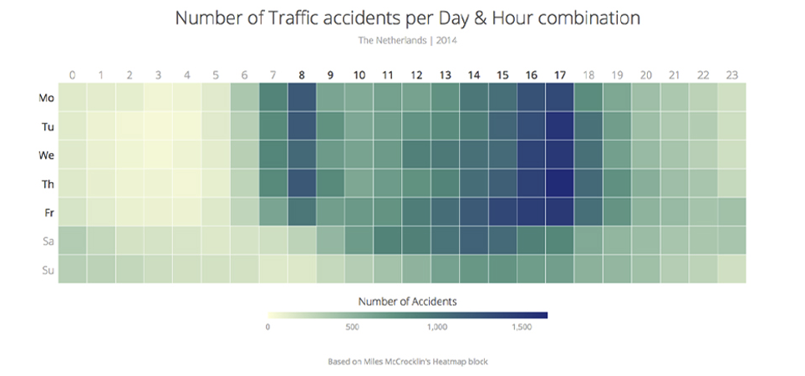
https://think.design/services/data-visualization-data-design/heatmap/

The heat map titled "Number of Traffic Accidents per Day & Hour Combination" illustrates the distribution of traffic accidents across different days of the week and hours of the day for the Netherlands in 2014. The primary goal of this heat map is to provide a clear and detailed view of traffic accident patterns by day and hour. the chart helps to identify peak times for traffic accidents, uncover patterns, and inform decision-making for traffic management and road safety improvements.

Attributes of Color:
This chart uses a color scheme ranging from light green to dark blue. While this shows variation in the number of accidents, the choice of colors might not be the most intuitive, colors like red are used to indicate higher intensity. The saturation levels for the chart varies with lighter shades indicating fewer accidents and darker shades indicating more accidents and the luminance differences between the light green and dark blue help show the gradient, but the contrast could be improved for better clarity.

Color Schemes:
The chart uses a color scheme, which is appropriate for representing ordered data like the number of accidents. However, the transition from green to blue might be challenging for some viewers to distinguish, especially those with color vision, while the hues chosen (green to blue) are close on the color wheel, A more distinct hue difference, such as a color from light blue to dark red, might improve differentiation. Lastly Increasing saturation contrast could help make the differences more apparent and for the lightness increasing the contrast in lightness can further enhance readability.

Common Mistakes in the Use of Colors:
The green-to-blue blend can be challenging to interpret, especially for those with color vision. Using colors that are too similar can confuse viewers while the lack of adequate contrast between the colors makes it difficult to distinguish between different levels of accidents.

In summary, the color blend here for this chart can be difficult for colorblind individuals to distinguish. so, using a blend that isn't colorblind-friendly reduces the effectiveness of the chart as it may not be easily interpretable by all audience, leading to misinterpretation of the data.
Recommendations
For this chart, I will recommend considering using a colorblind-friendly color with higher contrast, such as a colors like orange that are easily distinguishable and implementing a color scheme that accommodates color vision deficiencies, making the chart more accessible to all viewers.
By addressing these issues, the heat map chart can be made more effective and accessible, ensuring that the data is communicated clearly to a wider audience.

HOMEWORK 3 PART 3: REFLECTION

Reflecting on these visual designs and overall chapter 4 enhances my overall visualization skills reinforcing the importance of using color effectively and understanding how various principles can impact the clarity and accessibility of the data being presented to the audience.
What I Learned from Visual Design
- So far so good, I have learned a lot from visualization principles and from chapter 4 such as ensuring that the chosen color schemes are accessible to individuals with color blindness is crucial. This involves selecting colors that are distinguishable by all viewers.
- Maintaining and utilizing of consistent color schemes helps in maintaining clarity and making visualizations more intuitive for the audience.
- Ensure not using unnecessary colors which does not contribute to clarity as this distract the viewers and can obscure the data's message.
- Ensure am not using excessive color or overusing a wide range of color without a clear purpose of using them in any visual design, using excessive color makes it difficult for audience to focus on the most important message on the visual design

Application of Principles in Future Assignment
For future assignments when designing visual design chart, I will apply all these principles to ensure that the visualizations are both clear and accessible for all audience. For instance, when creating a sales dashboard, I will:
- Implement a color-blind-friendly color and use consistent colors to represent different regions or product categories. This ensures that all audience can easily interpret the data.
- Ensure the removal of unnecessary elements such as excessive gridlines to focus on the data points. This keeps the chart clean and easy to read.

When creating reports, especially those involving complex data sets, I will:
- Apply Gestalt Principles Which use the 4 PRINCIPLES: SIMILARITY, PROXIMITY, ENCLOSURE AND CONNECTION making it easier for readers to understand the relationships and trends. For example, in a financial report, grouping revenue, expenses, and profit margins closely can highlight their interconnections.
- Ensuring Clarity with the use of Legends and Labels by placing legends and labels in a way that provides context without concealing the visualization. Clear titles and axis labels help audience quickly grasp the data being presented.

By integrating these lessons and principles, I can enhance the effectiveness of my visual designs, making them more clear, accessible, and concise. These reflections and applications underscore the importance of thoughtful visual design in effectively conveying information to the audience. consistently applying these principles, I believe I can create a great, clear and concise visualizations that is highly functional and inclusive to all audience.

